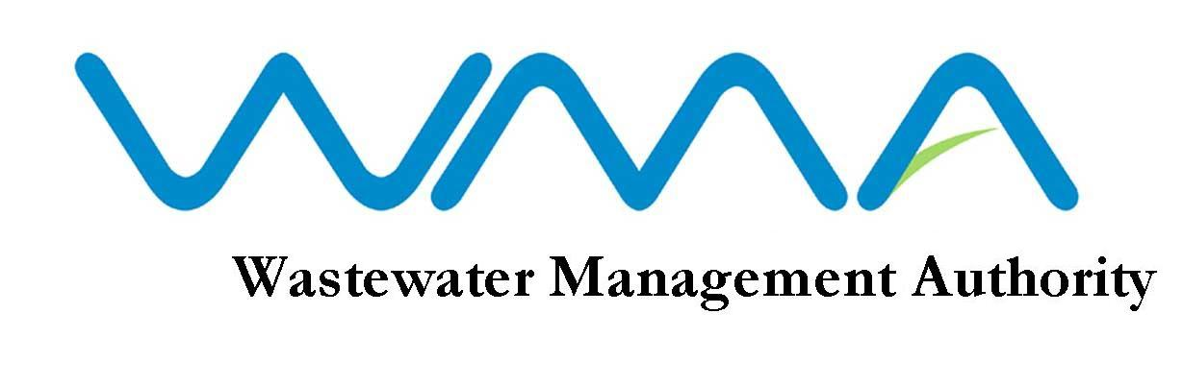
WMA is Recruiting

The Wastewater Management Authority (WMA) is a corporate body which has as its core responsibility the protection of water resources and the health of the population in Mauritius through the management and control of wastewater collection, treatment and disposal. The Authority is expected to handle an investment programme of about 4 billion MUR over the next three years.

The WMA is looking for dynamic, motivated and result-oriented candidates to fill the following positions on permanent basis:

- Engineer/Senior Engineer (Civil)

Qualifications
Candidates should be :
- registered as Professional Engineer (Civil) with the Council of Registered Professional Engineers of Mauritius under Section 13 of Act No.49 of 1965, as subsequently amended; and
- computer literate.

Salary
In the scale of: Rs 29, 400 x 775 – 32,500 x 925 – 37,125 x 1225 – 40,800 x 1525 – 49,950 x 1625 –62,950.

- Technical Officer (Civil)

Qualifications
- A Cambridge School Certificate with credit in at least five subjects including English Language, Mathematics and Physics obtained at not more than two sittings or Passes not below Grade C in at least five subjects including English Language, Mathematics and Physics obtained at not more than two sittings at the General Certificate of Education “Ordinary Level” provided that at one of the sittings, passes have been obtained either (i) in five subjects including English Language with at least Grade C in any two subjects or (ii) in six subjects including English Language with at least Grade C in any one subject.

Note
Candidates not possessing a credit in English Language at the Cambridge School Certificate will also be considered provided they possess passes in at least two subjects at “Principal Level” and one subject at “Subsidiary Level” as well as the General Paper obtained on one certificate at the Cambridge Higher School Certificate Examinations.

- A Cambridge Higher School Certificate or Passes in at least two subjects obtained on one certificate at the General Certificate of Education “Advanced Level”.

- A Diploma in Civil Engineering from a recognized institution.

OR
Equivalent qualifications to A, B and C above acceptable to the Board.

- Candidates should be computer literate.

Qualification at A above should have been obtained prior to qualification at B above.

Candidate should produce written evidence of knowledge claimed.
Salary
In the scale of: Rs 19,575 x 475 – 21, 950 x 625 – 23,200 x 775 – 32,500 x 925 – 37,125 x 1225 – 40,800 x 1525 - 42,325

AGE LIMIT

Candidates, unless in the public sector, should not have reached their 40th birthday by the closing date of this advertisement.

DUTIES / MODE OF APPLICATION
Application forms and detailed list of duties are available at the Human Resource Section of the WMA and can be downloaded from our website: http://www.wmamauritius.mu. Qualified candidates should submit a comprehensive CV, copies of all academic and professional certificates and evidence of experience claimed. The post/s applied for should be clearly marked on the left hand corner of the envelope.

CLOSING DATE OF APPLICATION
If you feel challenged by the above positions, and you have the required profile, please send your applications, through registered post, to: The Officer-In-Charge, Wastewater Management Authority, The Celicourt, Sir Celicourt Antelme St, Port Louis, not later than Tuesday 27 August 2019 at 15.30 hrs.

Note:

- Only the best qualified candidates will be convened for interview.
- The WMA reserves the right not to fill the vacancies as a result of this advertisement.
- Incomplete/applications not made on the prescribed form as well as applications received at the WMA after the closing date, will not be considered.
- Candidates who possess an equivalent qualification to the prescribed qualification are requested to submit an Equivalence Certificate from Mauritius Qualification Authority/Tertiary Education Commission, as appropriate.

Wastewater Management Authority
9th Floor, The Celicourt
Sir Celicourt Antelme Street
Port Louis
Tel : 206 3000

08 August 2019

WMA IS AN EQUAL OPPORTUNITY EMPLOYER

