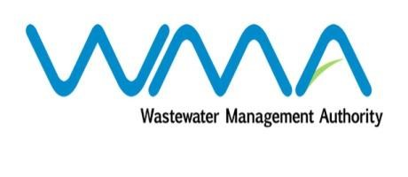

Wastewater Management Authority

Award of Procurement Contract
Notice under section 40(7) of the Public Procurement Act 2006

This is to notify that, following the bidding exercise carried out by the Wastewater Management Authority for the procurement of Contract No. WW379S – Provision of Intruder Alarm System with a 24-hr Full Monitoring Response at WMA Pumping Station, the contract has been awarded to Proguard Ltd, of Seeneevassen Road, Palma, Quatre Bornes, for a total amount of MUR 1,592,508.73, including VAT.

Wastewater Management Authority
Dated 10 May 2018

