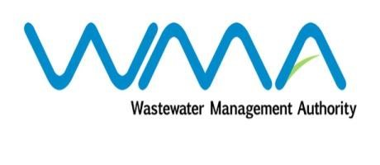

Wastewater Management Authority

Award of Procurement Contract
Notice under section 40(7) of the Public Procurement Act 2006

This is to notify that, following the bidding exercise carried out by the Wastewater Management Authority for Quotation 159 of 2018/2019- Supply, Installation, Testing and Commissioning of Navigation Buoy at Baie Du Tombeau Sea Outfall, the contract has been awarded to Remihens- Poseidon JV of Office 1, Level 3, Motorway M2, Riche Terre, for a total amount of MUR 1,914,300.00, excluding VAT and including Contingencies.

J.A Radhay
Ag. General Manager
Wastewater Management Authority
Dated 18 January 2019

