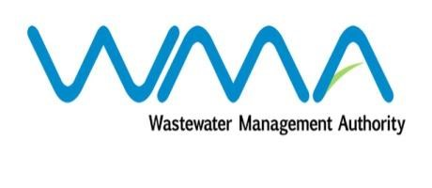

Wastewater Management Authority

Award of Procurement Contract
Notice under section 40(7) of the Public Procurement Act 2006

This is to notify that, following the bidding exercise carried out by the Wastewater Management Authority for the procurement of Contract WW388G – Supply and Commissioning of Computers and Convertible Laptops/Tablets, the contract has been awarded as follows:
- Lot 1.0 – Computers: Pascal Computer Services Ltd, of 40/42 St Georges Street, Port Louis, for a total amount of MUR 4,991,304.35, excluding VAT.
- Lot 2.3 (Option 3) – Convertible Laptops/Tablets: Softel Computer Services Ltd, of 22 Wellington St, Port Louis, for a total amount of MUR 683,400.00, excluding VAT.

Dated 04 October 2018
Ag. General Manager
Wastewater Management Authority

