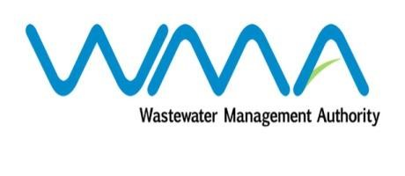

Wastewater Management Authority

Award of Procurement Contract
Notice under section 40(7) of the Public Procurement Act 2006

This is to notify that, following the bidding exercise carried out by the Wastewater Management Authority for the Contract WW397W – Supply, Installation, Testing and Commissioning of Wastewater Pump and Accessories at Wastewater Pumping Station, the contract has been awarded as follows:-
Name of Bidder | Address | Number of Sites | Contract Price (Rs)  Excl VAT
Sotravic Ltée | Industrial Zone, La Tour Koenig | 10 | 5,035,377.00
Remihens Co Ltd | Office 1, Level 3, Motorway M2, Riche Terre | 1 | 669,500.00

………………….
J.A.Radhay
Ag. General Manager
Wastewater Management Authority
26 February 2019

