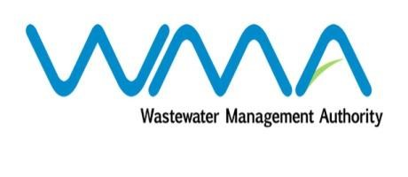

Wastewater Management Authority

Award of Procurement Contract
Notice under section 40(7) of the Public Procurement Act 2006

This is to notify that, following the bidding exercise carried out by the Wastewater Management Authority for the Contract WW399W – Supply, Installation, Testing and Commissioning of One Wastewater Pump and Accessories at Baie du Tombeau BT1 Pumping Station, the contract has been awarded to Sotravic Ltée, of Industrial Zone, La Tour Koeing, in the amount of Rs 2,501,949.20, Incl of VAT.

J.A.Radhay
Ag. General Manager
Wastewater Management Authority
22 January 2019

