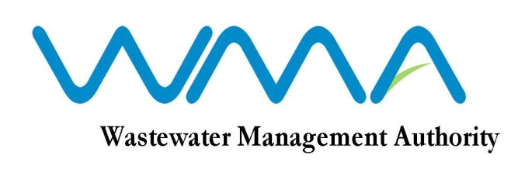

WASTEWATER MANAGEMENT AUTHORITY

INVITATION FOR BIDS (IFB)

Contract WW 389W - Sewerage Project at Valentina, Phoenix

IFB: WMA/11/18

1. The Wastewater Management Authority invites sealed bids from eligible and qualified bidders for the Sewerage Project at Valentina, Phoenix – Contract WW 389W in accordance with the ITB, Conditions of Contract, Specifications and other requirements set out in the Bidding Document.

2. This Bid is open to Contractors registered with CIDB under the class of Civil Engineering Works.

3. Interested eligible bidders may consult the Bidding Document at the Registry on the 6th Floor at the address given below from 9.00 hrs to 12.00 hrs and 12.30 hrs to 15.30 hrs on working days.
4. Request for clarification on bidding documents may be made to the Wastewater Management Authority at the address below:

The Officer in Charge
Wastewater Management Authority
9th Floor, The Celicourt
Sir Celicourt Antelme Street
Port Louis
Mauritius

5. A complete set of Bidding Document may be purchased by interested bidders at the Finance Section, 3rd Floor at the address below and upon payment of a fee Rs 2,500.00 per set (time 9.00 hrs to 12.00 hrs and 12.30 hrs to 14.30 hrs on working days). The method of payment will be either by crossed bank cheque to the order of the Wastewater Management Authority or by cash.

Wastewater Management Authority
3rd Floor, The Celicourt
Sir Celicourt Antelme Street
Port Louis
Mauritius

6. A pre-bid meeting will be held on 12 July 2019 at 10:00 hrs in the Conference Room of the WMA Head Office 9th Floor, The Celicourt Building, Sir Celicourt Antelme Street, Port Louis, Mauritius, followed by a site visit.

7. Bids duly filled in and contained in a sealed envelope marked “SEWERAGE PROJECT AT VALENTINA, PHOENIX” should be addressed to the Officer in Charge, Wastewater Management Authority and shall be deposited in the Tender Box, on the 6th floor at the address below at or before 13:30 hrs (local time) on Thursday 08 August 2019. Late Bids will be rejected.

8. Bids will be opened physically in the presence of the bidders/bidders’ representatives who choose to attend in person in the Board Room, 9th Floor of the Wastewater Management Authority Head Office at 14:00 hrs on the same day. Bids received after the specified time and date shall not be considered.

Date : 02 July 2019

