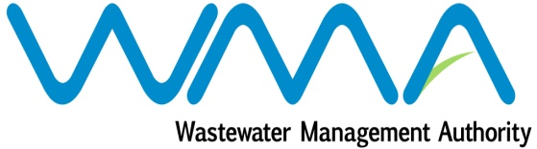

INVITATION FOR BIDS

Authorised under Section 17 of the Public Procurement Act 2006

WMA/OAB/431G – IFB 22/19
Procurement of D/CAB 4X4 Vehicles

The Wastewater Management Authority (WMA) invites bids from eligible and qualified local bidders for the supply of D/CAB 4X4 Vehicles.

The closing date for submission of bids is on Monday 21 October 2019 at 13.00 hrs.
For further details, please consult the Public Procurement Portal on: publicprocurement.govmu.org

Wastewater Management Authority
The Celicourt,
Celicourt Antelme Street
Port Louis
18 September 2019

