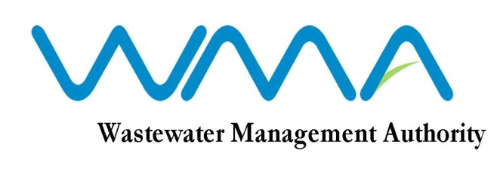
WASTEWATER MANAGEMENT AUTHORITY

INVITATION FOR BIDS (IFB)

CONTRACT WW 334W

SEWERAGE PROJECT AT CAMP ROUILLARD,
EAU COULEE

CPB Reference No.: CPB/54/2019

1. The Wastewater Management Authority invites sealed bids from eligible and qualified bidders for Contract WW 334W - Sewerage Project at Camp Rouillard, Eau Coulee in accordance with the ITB, Conditions of Contract, Specifications and other requirements set out in the Bidding Document.

2. This Bid is open to Contractors registered with CIDB under the class of Civil Engineering Works.

3. Interested eligible bidders may consult the Bidding Document at the Registry on the 6th Floor at the address given below from 9.00 hrs to 12.00 hrs and 12.30 hrs to 15.30 hrs on working days.
4. Request for clarification on bidding documents may be made to the Wastewater Management Authority at the address below:

The Officer in Charge
Wastewater Management Authority
9thFloor, The Celicourt
Sir Celicourt Antelme Street
Port Louis
Mauritius

5. A complete set of Bidding Document may be purchased by interested bidders at the Finance Section, 3rd Floor at the address below and upon payment of a fee Rs 2,500.00 per set (time 9.00 hrs to 12.00 hrs and 12.30 hrs to 14.30 hrs on working days). The method of payment will be either by crossed bank cheque to the order of the Wastewater Management Authority or by cash.
Wastewater Management Authority
3rdFloor, The Celicourt
Sir Celicourt Antelme Street
Port Louis,Mauritius

6. A pre-bid visit will be held on 08 October 2019 at 10:00 hrs (local time) followed by a pre-bid meeting which will be held on same day at 13:15 hrs (local time) in the Conference Room of the WMA Head Office 9th Floor, The Celicourt Building, Sir Celicourt Antelme Street, Port Louis, Mauritius.

7. Bids duly filled in and contained in a sealed envelope marked“CONTRACT WW 334W - SEWERAGE PROJECT AT CAMP ROUILLARD, EAU COULEE” CPB Reference No. CPB/54/2019 should be addressed to The Chief Executive, Central Procurement Board, and shall be deposited in the Tender Box, on the 1st floor at the address below up to 13.30 hours (local time) at latest on 13 November 2019.

The Central Procurement Board
1st Floor, Social Security House,
Julius Nyerere Avenue, Rose-Hill,
Mauritius

8. Bids will be opened physically in the presence of the bidders/bidders’ representatives who choose to attend in person in the Conference Room, 1st Floor of The Central Procurement Board at 14:00 hrs on the same day. Bids received after the specified time and date shall not be considered.

Date :26 September 2019

