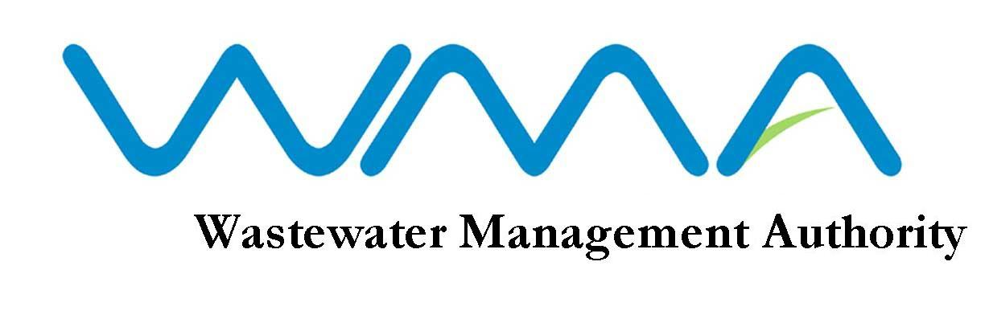

NOTICE OF VACANCY

Post of General Worker/Security Guard (On Contract)

QUALIFICATIONS :

- The Certificate of Primary Education or show proof of literacy
- A good health and a sound physique
- Knowledge of security/watch keeping duties
- Clean recent morality certificates, dated not more than six months

Note:
General Workers/Security Guards will be required to work on shift, covering a 24-hour service including Saturdays, Sundays and Public Holidays and officially declared cyclone days.

SALARY
Rs 15,000 monthly

AGE LIMIT
Candidates should not have reached their 48th birthday by the closing date of this advertisement.

MODE OF APPLICATION
Application forms for the above post is available at the Human Resource Section of the WMA and can be downloaded from our website: http://www.wmamauritius.mu.

EXTENSION NOTICE /CLOSING DATE
The closing date for submission of application for the post of General Worker/Security Guard (On Contract) has been extended to Monday 20 January 2020 at 15.30 hrs.

Applications, through registered post, should reach The Officer in Charge, Wastewater Management Authority, The Celicourt, Sir Celicourt Antelme St, Port Louis.

Wastewater Management Authority
9th Floor, The Celicourt
Sir Celicourt Antelme Street
Port Louis
Tel : 206 3000

23 December 2019

WMA IS AN EQUAL OPPORTUNITY EMPLOYER



