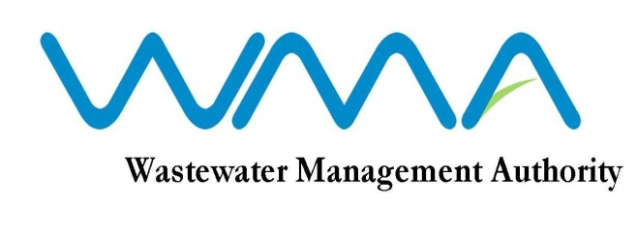
WASTEWATER MANAGEMENT AUTHORITY
INVITATION FOR BIDS (IFB)
Contract No: WMA/OAB/441S, IFB No.: WMA/02/2020

Contract WMA/OAB/441S: Supply of a Customised Hosted Board Management System

- The Wastewater Management Authority invites sealed bids from eligible and qualified bidders for the Supply of a Customised Hosted Board Management System in accordance with the ITB, Conditions of Contract, Specifications and other requirements set out in the Bidding Document.

2. This Bid is open to local firms having experience in the above mentioned field.

3. Interested eligible bidders may consult the Bidding Document at the Registry on the 6th Floor at the address given below from 9.00 hrs to 12.00 hrs and 12.30 hrs to 15.30 hrs on working days.
4. Request for clarification on bidding documents may be made to the Wastewater Management Authority at the address below:

The Officer In Charge
Wastewater Management Authority
9th Floor, The Celicourt
Sir Celicourt Antelme Street
Port Louis
Mauritius

5. A complete set of Bidding Document may be purchased by interested bidders at the Finance Section, 3rd Floor at the address below and upon payment of a non-refundable fee Rs 500.00 per set (time 9.00 hrs to 12.00 hrs and 12.30 hrs to 14.30 hrs on working days). The method of payment will be either by crossed bank cheque to the order of the Wastewater Management Authority or by cash.
7. Bids duly filled in and contained in a sealed envelope marked “SUPPLY OF A CUSTOMISED HOSTED BOARD MANAGEMENT SYSTEM” should be addressed to the Officer In Charge, Wastewater Management Authority and shall be deposited in the Tender Box, on the 6th floor at the above address or before 13:30 hrs (local time) on Thursday, 27 February 2020. Late Bids will be rejected.

8. Bids will be opened physically in the presence of the bidders/bidders’ representatives who choose to attend in person in the Board Room, 9th Floor of the Wastewater Management Authority Head Office at 14.00 hrs on the same day. Bids received after the specified time and date shall not be considered.

Date : 24 January 2020

