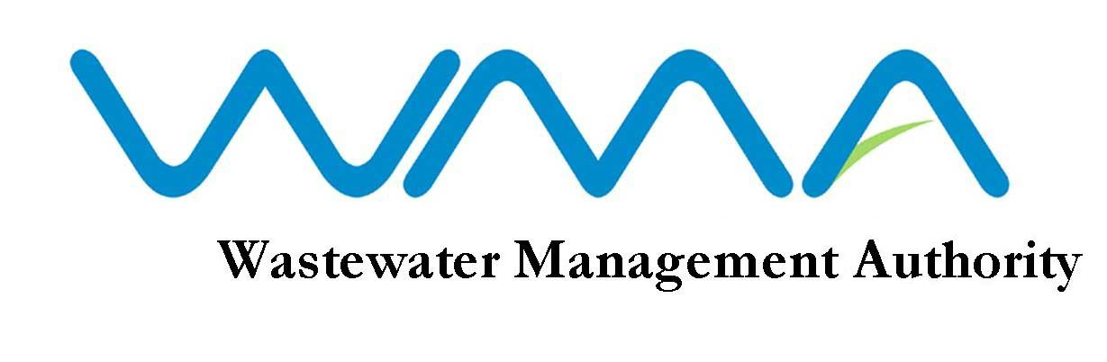

ADDENDUM FOR RFP 039/2020 ADVERTISEMeNT AS PUBLISHED IN:
Sunday times (SOUTH AFRICA): 16 FEBRUARY 2020

RFP 039/2020: Transaction Advisory Services for the New Roche Bois Pumping Station and the Baie du Bombeau Wastewater treatment plant (Mauritius)

Bidders are to take note of the following amendments;

- A first Briefing session was held on 25 February 2020 with participation of mostly local prospective bidders (South Africa).
- 04 March 2020 – Compulsory Local Bidders’ Briefing Session (Mauritian) @ 13:00 South African time via SKYPE (Search for ‘Ivo Phiri’)
- 10 March 2020 – Last day for the submission of bid queries;
- 13 March 2020 – The DBSA response to the final set of queries;
- 23 March 2020 – Bid Closing Date at 11:00 South African time

Amended Tender Documents and further information is available on the DBSA’s website (www.dbsa.org)l as at 02 March 2020 close of business.

