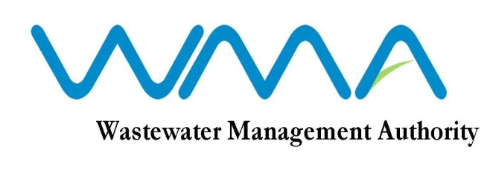
WASTEWATER MANAGEMENT AUTHORITY
INVITATION FOR BIDS
Contract No: RFP 039/2020

RFP039/2020: Procurement of Transaction Advisory Services for the BOT Project for new Roche Bois Pump Station and new Baie du Tombeau WWTP

- The Development Bank of Southern Africa (DBSA) on behalf of the Wastewater Management Authority (WMA) invites sealed bids from eligible and qualified bidders for the Procurement of Transaction Advisory Services for the BOT Project for new Roche Bois Pump Station and Baie du Tombeau Waste Water Treatment Plant in accordance with the Invitation To Bid (ITB), Conditions of Contract, Specifications and other requirements set out in the Bidding Document.

- This Bid is open to both local and international Bidders.

- Interested and eligible bidders may download the ITB from the WMA’s website on the following link https://www.wmamauritius.mu/procurement/invitation-of-bids/ or alternatively on the DBSA’s website on the following link https://www.dbsa.org/EN/TenderInfo/Pages/default.aspx effective on 17 February 2020.

- Request for clarification on bidding documents may be made in accordance with the Invitation to Bid.

- A non-compulsory site visit will be undertaken by the WMA at 11.00am on 24 February 2020. Meeting point shall be at the Roche-Bois Pumping Station, Port-Louis and Prospective bidders, who choose to attend the visit, shall register their attendance on site.

- A COMPULSORY Briefing Session will be held at the DBSA’s offices at 1258 Lever Road, Headway Hill, Midrand in South Africa on 25 February 2020 at 11:00 hrs South African time.

- The Closing Date for the submission of Proposals for the above ITB is on 09 March 2020 at 12:00 (midday) South African Time. Bids may be submitted at the Tender Box situated at The Welcome Centre, DBSA, 1258 Lever Road, Headway Hill, Midrand. Late Bids will be rejected.

Date : 17 February 2020

