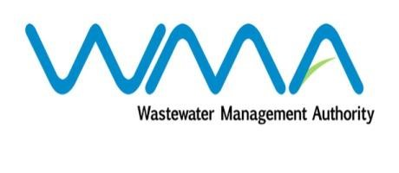

Wastewater Management Authority

Award of Procurement Contract
Notice under section 40(7) of the Public Procurement Act 2006

This is to notify that, following the bidding exercise carried out by the Wastewater Management Authority for the Contract 438W – Procurement of Civil Works at Montagne Jacquot Treatment Plant and Fort Victoria and Pointe Aux Sables Pumping Stations, the contract has been awarded as follows:-
Name of Bidder | Address | Contract Price (Rs)  Incl of VAT
JV Remihens Co Ltd & SMS Contracting Ltd | Office 1, Level 3, Motorway M2, Riche Terre | 6,429,719.00

Wastewater Management Authority
19 June 2020

