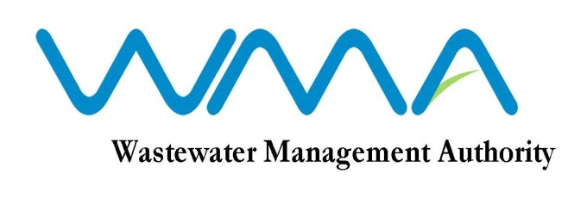
INVITATION FOR BIDS

RFP 117/2020: Procurement of Transaction Advisory Services for the BOT Project for new Roche Bois Pump Station and new Baie du Tombeau WWTP

- The Development Bank of Southern Africa (DBSA) on behalf of the Wastewater Management Authority (WMA) invites sealed bids from eligible and qualified bidders for the Procurement of Transaction Advisory Services for the BOT Project for new Roche Bois Pump Station and new Baie du Tombeau Waste Water Treatment Plant in accordance with the Invitation To Bid (ITB), Conditions of Contract, Specifications and other requirements set out in the Bidding Document.

- This Bid is open to both local and international Bidders.

- Interested and eligible bidders may download the RFP from the DBSA’s website on the following link https://www.dbsa.org/EN/TenderInfo/Pages/default.aspx effective on 29 June 2020 as from 00.00hrs African Time.

- The mode of submission of Bids will be electronic as per the instructions of the Bidding Document.

- Request for clarification on bidding documents may be made in accordance with the Invitation to Bid.

- A NON-COMPULSORY Briefing Session will be held by the DBSA on 07 July 2020 at 13h00 Central African time.

- The Closing Date for the submission of Proposals for the above ITB is on 27 July 2020 at 00h00 Central African Time. Bids shall be submitted electronically by following the instructions in the ITB. Late Bids will be rejected.

Date : 29 June 2020

