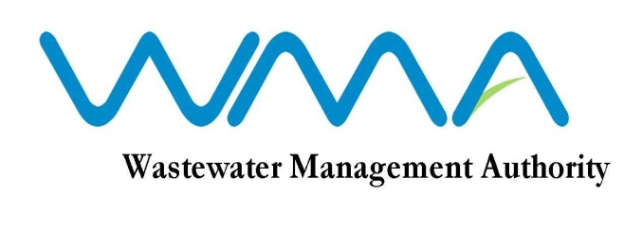
WASTEWATER MANAGEMENT AUTHORITY

INVITATION FOR BIDS (IFB)

(Authorised under Section 14(2) of the Public Procurement Act 2006 as amended)
INVITATION FOR BIDS (IFB)
CONTRACT WW 351 W- REHABILITATION/PROVISION OF SEWERAGE INFRASTRUCTURE AT RESIDENCE ATLEE & ENVIRONS, CUREPIPE CHA PHASE IV

CPB /27/2020

1. The Wastewater Management Authority invites sealed bids from eligible and qualified bidders for Contract WW 351 W – Rehabilitation/Provision of Sewerage Infrastructure at Residence Atlee & Environs, Curepipe- CHA Phase IV – CPB /27/2020 in accordance with the ITB, Conditions of Contract, Specifications and other requirements set out in the Bidding Document.

2. This Bid is open to Contractors registered with CIDB under the class of Civil Engineering Works.

3. Interested eligible bidders may consult the Bidding Document at the Registry on the 6th Floor at the address given below from 9.00 hrs to 12.00 hrs and 12.30 hrs to 15.30 hrs on working days.
4. Request for clarification on bidding documents may be made to the Wastewater Management Authority at the address below:

The Officer in Charge
Wastewater Management Authority
9th Floor, The Celicourt
Sir Celicourt Antelme Street
Port Louis
Republic of Mauritius

5. A complete set of Bidding Document may be purchased by interested bidders at the Finance Section, 3rd Floor at the address below and upon payment of a fee Rs 2,500.00 per set (time 9.00 hrs to 12.00 hrs and 12.30 hrs to 14.30 hrs on working days). The method of payment will be either by crossed bank cheque to the order of the Wastewater Management Authority or by cash.
Wastewater Management Authority
3rd Floor, The Celicourt
Sir Celicourt Antelme Street
Port Louis,
Republic of Mauritius
6. A Pre-Bid visit shall take place in the presence of representatives of prospective bidders and that of the Employer.
The meeting place of the Pre-Bid visit will be at the entrance of Residence Atlee along Gustave Collin Street, Curepipe as follows:
Date: 18 August 2020
Time: 10 hrs
The Pre-Bid Visit will be followed by a Meeting at the Head Office of the Wastewater Management Authority (WMA) as follows:
Venue: WMA Head Office, 7th Floor, Conference Room, The Celicourt, Sir Celicourt Antelme Street, Port Louis.
Time: 13.30 hrs.
7. Bids duly filled in and contained in a sealed envelope marked “CONTRACT WW 351 W –REHABILITATION/PROVISION OF SEWERAGE INFRASTRUCTURE AT RESIDENCE ATLEE &ENVIRONS , CUREPIPE-CHA PHASE IV” should be addressed to The Chief Executive, Central Procurement Board, and shall be deposited in the Tender Box, at the address below at or before 13:30hrs (local time) on 30 September 2020. Late Bids will be rejected.
The Central Procurement Board
1st Floor, Social Security House,
Julius Nyerere Avenue, Rose-Hill,
Republic of Mauritius

8. Bids will be opened physically in the presence of the bidders/bidders’ representatives who choose to attend in person in the Conference Room, 1st Floor of Central Procurement Board at 14.00 hrs on the same day. Bids received after the specified time and date shall not be considered.

Date : 03 August 2020

