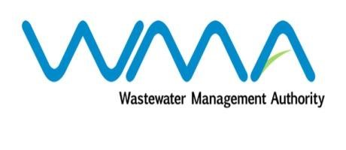

Wastewater Management Authority

Award of Procurement Contract
Notice under section 40(7) of the Public Procurement Act 2006

This is to notify that, following the bidding exercise carried out by the Wastewater Management Authority for the procurement of Contract 435W – Supply, Installation and Commissioning of Half-Bridge Clarifiers and Associated Works at Flacq Wastewater Treatment Plant, the contract has been awarded to Remihens Co Ltd, of Office 1, Level 3, Motorway M2, Riche Terre, for a total amount of MUR 3,988,063.27, including VAT.

Wastewater Management Authority
Dated 09 November 2020

