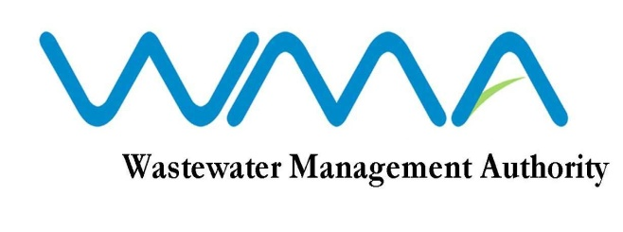
WASTEWATER MANAGEMENT AUTHORITY

INVITATION FOR BIDS (IFB)

(Authorised under Section 16 of the Public Procurement Act 2006)

CONTRACT WW 410C: CONSULTANCY SERVICES FOR DETAILED DESIGN, PREPARATION OF BIDDING DOCUMENTS AND SUPERVISION OF WORKS FOR LOT 1: BAIN DES DAMES AND LOT 2: CARO LALO, VALLÉE DES PRÊTRES

OPEN NATIONAL BIDDING
WMA/IFB/2021/313

- The Wastewater Management Authority (WMA) is proceeding with a Request for Proposals online and is inviting eligible and qualified Consultants through the Government eProcurement System for the CONTRACT WW 410C: CONSULTANCY SERVICES FOR DETAILED DESIGN, PREPARATION OF BIDDING DOCUMENTS AND SUPERVISION OF WORKS FOR LOT 1: BAIN DES DAMES AND LOT 2: CARO LALO, VALLÉE DES PRÊTRES in accordance with the ITC, Conditions of Contract, Terms of Reference and other requirements set out in the Invitation for Proposal.

- Participation is limited to Consultants of Mauritian nationals or entities incorporated in Mauritius. Joint Ventures should be among entities incorporated in Mauritius.

- This Invitation for Proposal is open to Consultants registered with CIDB.

- Request for clarification on bidding documents must be made online through the e-procurement system no later than Fourteen (14) days prior to the deadline set for the submission of bids and response would be made no later than 7 days prior to the deadline set for the submission of bids.

- A pre-proposal conference will be on Friday 26 February 2021 at 10.00 a.m at address given hereunder.

The Wastewater Management Authority,
9th Floor, The Celicourt
Sir Celicourt Antelme Street,
Port-Louis,
Republic of Mauritius

- Proposals shall be submitted online on the e-procurement system by Tuesday 23 March 2021 up to 01.29 PM (Local Time) at latest. Proposals received after the specified time and date shall not be considered.

- Consultants who have submitted bids online by the closing date and time shall decrypt and re-encrypt their bids on Tuesday 23 March 2021 as from 02.31 PM till Thursday 25 March 2021 at 01.29 PM.

- Proposals will be opened online in the presence of the consultant’s representatives who choose to attend at the address given hereunder on Thursday 25 March 2021 as from 01.30 PM.

The Wastewater Management Authority,
9th Floor, The Celicourt
Sir Celicourt Antelme Street,
Port-Louis,
Republic of Mauritius

Date: 19 February 2021

