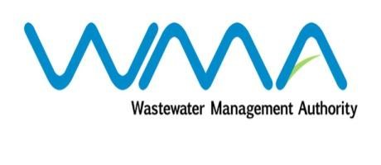

Wastewater Management Authority

Award of Procurement Contract
Notice under section 40(7) of the Public Procurement Act 2006

This is to notify that, following the bidding exercise carried out by the Wastewater Management Authority for the procurement of Contract 461W – Refurbishment Works on Sand Filters at St Martin Wastewater Treatment Plant, the contract has been awarded to Remihens Co Ltd, of Office 1, Level 3, Motorway M2, Riche Terre, for a total amount of MUR 11,709,650.00 exclusive of VAT.

Wastewater Management Authority
Dated 05 February 2021

