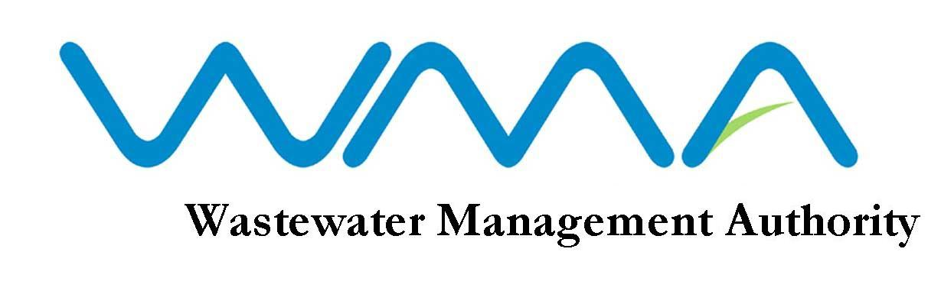
VACANCY

The Wastewater Management Authority (WMA) is a corporate body which has as its core responsibilities the protection of water resources and the health of the population in Mauritius through the management and control of wastewater collection, treatment and disposal. With the expansion of its activities and implementation of new wastewater projects, the Authority is expected to handle an investment programme of about 4 billion MUR over the next three years.

The Authority is inviting applications from high caliber professionals for the following positions :

QUALIFICATIONS
1. FINANCIAL MANAGER – PERMANENT/(ON CONTRACT)

- Qualified member of a professional accounting body recognized by the CCAB (Consultative Committee of Accountancy Bodies) or possess an equivalent qualification acceptable to the Board.

EXPERIENCE

- Reckon at least 10 years’ experience in a senior financial management position in a relevant organization preferably including the utility or private sector;
- Are a change-manager with a successful track record of proactive management;
- Possess strong business planning and financial modeling skills;
- Are able to establish good working relationship at all levels within the organisation and with a range of institutions including the public sector and industry;
- Have good communication skills; and
- Are computer literate and have the ability to work at a detailed level and to operate the computerized accounting systems.
Candidates should produce written evidence of any experience/knowledge claimed

PERMANENT POSITION
Salary: In the scale of: Rs 46,900 x 1525 – 49,950 x 1625 – 62,950 x 1850 – 68,500 x 1950 – 70,450 Benefits: As per PRB 2016

CONTRACTUAL POSITION

Salary: Negotiable and will commensurate with qualifications and experience.
Benefits : Travelling Allowance & Gratuity
Duration of contract: Two years, renewable upon satisfactory performance

2. ENGINEER/SENIOR ENGINEER (CIVIL) - PERMANENT
QUALIFICATIONS

- Registered as Professional Engineer (Civil) with the Council of Registered Professional Engineers of Mauritius under Section 13 of Act No.49 of 1965, as subsequently amended; and

- Computer Literate;

Candidates should produce written evidence of any experience/knowledge claimed

SALARY
In the scale of: Rs 29,400 x 775 – 32,500 x 925 – 37,125 x 1225 – 40,800 x 1525 – 49,950 x 1625 – 62,950

3. INTERNAL AUDITOR – PERMANENT
QUALIFICATIONS

- Member of one of the following bodies-

- The Institute of Chartered Accountants of England and Wales
(b)The Institute of Chartered Accountants of Scotland
(c)The Institute of Chartered Accountants of Ireland
(d)The Association of Chartered Certified Accountants
(e)The Chartered Institute of Management Accountants
(f)The Chartered Institute of Public Finance and Accountancy
OR
An equivalent professional accountancy qualification acceptable to the Board.

EXPERIENCE

- Reckons at least two years’ post qualification experience in accountancy and auditing in a senior position;
- Computer literate;
- Possesses good analytical and communication skills; and
- Has a high sense of personal credibility and integrity.

Candidates should produce written evidence of any experience/knowledge claimed

SALARY
Salary: In the scale of: Rs 28, 625 x 775 – 32,500 x 925 – 37,125 x 1225 – 40,800 x 1525 – 49,950 x 1625 – 56,450.
Benefits: As per PRB 2016

4. TECHNICAL OFFICER (CIVIL) - (ON CONTRACT)
QUALIFICATIONS
- A Cambridge School Certificate with credit in at least five subjects including English Language, Mathematics and Physics obtained at not more than two sittings or Passes not below Grade C in at least five subjects including English Language, Mathematics and Physics obtained at not more than two sittings at the General Certificate of Education “Ordinary Level” provided that at one of the sittings, passes have been obtained either (i) in five subjects including English Language with at least Grade C in any two subjects or (ii) in six subjects including English Language with at least Grade C in any one subject.
Note
Candidates not possessing a credit in English Language at the Cambridge School Certificate will also be considered provided they possess passes in at least two subjects at “Principal Level” and one subject at “Subsidiary Level” as well as the General Paper obtained on one certificate at the Cambridge Higher School Certificate Examinations.

- A Cambridge Higher School Certificate or Passes in at least two subjects obtained on one certificate at the General Certificate of Education “Advanced Level”.

- A Diploma in Civil Engineering from a recognized institution.
OR
Equivalent qualifications to A, B and C above acceptable to the Board.

- Candidates should be computer literate.

Qualification at A above should have been obtained prior to qualification at B above.

CONTRACTUAL POSITION
Salary: Negotiable and will commensurate with qualifications and experience.
Benefits: Travelling Allowance
Duration of contract: Two years, renewable upon satisfactory performance.

AGE LIMIT
Candidates applying for permanent post, unless in the public sector, should not have reached their 40th birthday by the closing date of this advertisement.

MODE OF APPLICATION
Application forms and detailed list of duties are available at the Human Resource Section of the WMA and can be downloaded from our website: http://www.wmamauritius.mu. Qualified candidates should submit a comprehensive CV, copies of all academic and professional certificates and evidence of experience claimed.

If you feel challenged by the above position and believe that you have the required profile, please send your application to: The Officer in Charge, Wastewater Management Authority, The Celicourt, Sir Celicourt Antelme St, Port Louis, not later than Monday 22 March 2021 at 15.30 hrs.

Note: 1. Only the best qualified candidates will be considered.
2. The WMA reserves the right not to make any appointment as a result of this advertisement.
3. The post applied for should be clearly marked on the left hand corner of the envelope.
4. Late/incomplete application or application not made on the prescribed form will not be considered.
5. Candidates who possess an equivalent qualification to the prescribed qualification are requested to submit an
Equivalence Certificate from Mauritius Qualification Authority/Tertiary Education Commission, as appropriate
Wastewater Management Authority
9th Floor, The Celicourt
Sir Celicourt Antelme Street
Port Louis
Tel : 206 3000/206 3056
26 February 2021 WMA IS AN EQUAL OPPORTUNITY EMPLOYER

