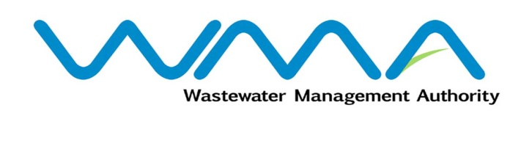 | Invitation for bids (IFb)  (Authorised Under Section 17 of The Public Procurement Act 2006)
WASTEWATER MANAGEMENT AUTHORITY
Open National Bidding

Procurement Reference No: WMA/OAB/468W – IFB 5/2021

Contract WW468W - Construction of Sewers Across A1 Road at Grand River North West
- The Wastewater Management Authority (WMA) is inviting bids from eligible and qualified bidders of Mauritian nationals or entities incorporated in Mauritius, through the Government E-Procurement System for the Construction of Sewers Across A1 Road at Grand River North West.
- Bidding documents may be downloaded from the E-Procurement System https://eproc.publicprocurement.govmu.org. IFB Reference Number on the system: WMA/IFB/2021/404
- Bids must be submitted online on the E-procurement System at latest by Monday 02 August 2021 up to 02:30 PM (Local Time).
- Bidders who have submitted bids online by the closing date and time shall decrypt and re-encrypt their bids from Monday 02 August 2021 from 02:31 PM till Wednesday 04 August 2021 up to 02:29 PM.
- Bids will be opened online in the presence of the bidders/ bidders’ representatives who choose to attend at the address given hereunder on Wednesday 04 August 2021 up to 04:00 PM.
The Wastewater Management Authority,
9th Floor, The Celicourt,
Sir Celicourt Antelme Street,
Port-Louis,
Mauritius.

- The Wastewater Management Authority reserves the right to accept or reject any bid and to annul the bidding process and reject all bids at any time prior to award of the Contract, without thereby incurring any liability to any Bidder.

08 July 2021

