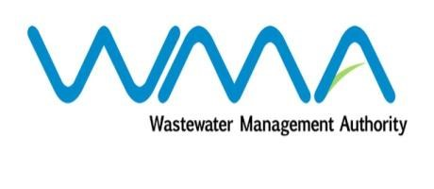

Wastewater Management Authority

Award of Procurement Contract
Notice under section 40(7) of the Public Procurement Act 2006

This is to notify that, following the bidding exercise carried out by the Wastewater Management Authority for Quotation 575 of 2021/22 – Supply, Installation, Testing and Commissioning of Wastewater Submersible Pumps and Accessories at Terre Rouge Wastewater Pumping Station, the contract has been awarded to Technic Water Services, of Edgar Laurent Street, Curepipe, for a total amount of Mauritian Rupees Two Million, Seven Hundred and Nine Thousand, Five Hundred and Eight Nine only (MUR 2,709,589.00), exclusive of VAT.

Wastewater Management Authority
Dated 05 October 2021

