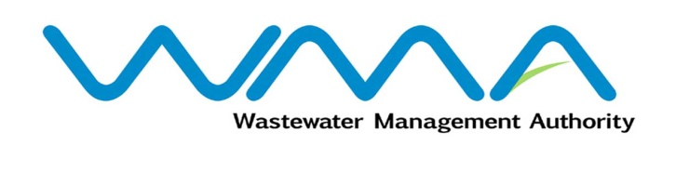 | Invitation for bids (IFb)  (Authorised Under Section 17 of The Public Procurement Act 2006)
WASTEWATER MANAGEMENT AUTHORITY

Procurement Reference: WMA/ONB/360W- IFB 13/17
Procurement of Rehabilitation/Provision of Sewerage Infrastructure at Residence Vallée Des Prêtres & Bernardin De St.Pierre Road.
- The Wastewater Management Authority (WMA) is inviting bids from eligible bidders of Mauritian nationals or entities incorporated in Mauritius, through the Government E-Procurement System for the Rehabilitation/Provision of Sewerage Infrastructure at Residence Vallée Des Prêtres & Bernardin De St.Pierre Road, as more fully described in the bidding document.
- Bidding documents may be downloaded from the E-Procurement System https://eproc.publicprocurement.govmu.org. Reference Number on the system: WMA/ONB/360W- IFB 13/17
- Bids must be submitted online on the E-procurement System at latest by Wednesday 15 December 2021 up to 13.29 (Local Time).
- Bidders who have submitted bids online by the closing date and time shall decrypt and re-encrypt their bids from Wednesday 15 December 2021 from 14.31 till Friday 17 December 2021 up to 13.29.
- Bids will be opened online in the presence of the bidders/ bidders’ representatives who choose to attend at the address given hereunder on Friday 17 December 2021 up to 16.00.
The Wastewater Management Authority,
9th Floor, The Celicourt,
Sir Celicourt Antelme Street,
Port-Louis,
Mauritius.
- The Wastewater Management Authority reserves the right to accept or reject any bid and to annul the bidding process and reject all bids at any time prior to award of the Contract, without thereby incurring any liability to any Bidder.

17 November 2021

