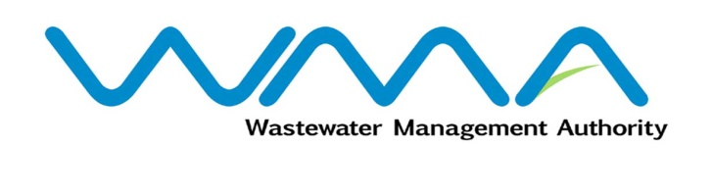 | Invitation for bids (IFb)  (Authorised Under Section 16 of The Public Procurement Act 2006)
WASTEWATER MANAGEMENT AUTHORITY
Procurement Ref. No: WMA/IFB/2021/608
Procurement of Contract WW 466C: Consultancy Services for Review of Feasibility Study, Detailed Design and Preparation of Bidding Documents for Sewerage Project at Camp Cavale & Robinson, Curepipe

OPEN NATIONAL BIDDING
- The Wastewater Management Authority (WMA) is proceeding with a Request for Proposals online and is inviting potential Consultants of Mauritian nationals or entities incorporated in Mauritius to submit their proposals through the Government e-Procurement System for the Procurement of Contract WW 466C: Consultancy Services for Review of Feasibility Study, Detailed Design and Preparation of Bidding Documents for Sewerage Project at Camp Cavale & Robinson, Curepipe

- Request for Proposal Documents may be downloaded from the e-Procurement System https://eproc.publicprocurement.govmu.org. Reference Number on the system: WMA/IFB/2021/608
- Proposals must be submitted online on the e-Procurement System at latest by Wednesday 12 January 2022 up to 13.29 (Local Time).
- Bidders who have submitted bids online by the closing date and time shall decrypt and re-encrypt their bids from Wednesday 12 January 2022 from 14.31 till Friday 14 January 2022 to 13.29.
- Bids will be opened online in the presence of the bidders/ bidders’ representatives who choose to attend at the address given hereunder on Friday 14 January 2022 from 13:30 to 15:30
The Wastewater Management Authority,
9th Floor, The Celicourt,
Sir Celicourt Antelme Street,
Port-Louis,
Mauritius

- The Wastewater Management Authority reserves the right to accept or reject any bid and to annul the bidding process and reject all bids at any time prior to award of the Contract, without thereby incurring any liability to any Bidder.

03 December 2021

