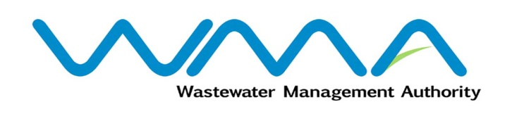 | Invitation for bids (IFb)  (Authorised Under Section 17 of The Public Procurement Act 2006)
WASTEWATER MANAGEMENT AUTHORITY
Procurement Reference: CPB/73/2021

Wastewater Project at La Source, Quatre-Bornes

and Environs – Phase 1
- The Wastewater Management Authority (WMA) is inviting bids from eligible bidders of Mauritian nationals or entities incorporated in Mauritius, through the Government E-Procurement System for the procurement of Wastewater Project at La Source, Quatre-Bornes and Environs- Phase 1, as more fully described in the bidding document.
- Bidding documents may be downloaded from the E-Procurement System https://eproc.publicprocurement.govmu.org. Reference Number on the system: WMA/IFB/2021/595
- A Pre-Bid Meeting and site visit shall take place on 26 January 2022 as detailed in the Bidding Document.
- Bids must be submitted online on the E-procurement System at latest by 14 February 2022 up to 13:30 hours (local time).
- Bidders who have submitted bids online by the closing date and time shall decrypt and re-encrypt their bids from 14 February 2022 from 14:31 hours (local time) till 16 February 2022 up to 14:00 hours (local time).
- Bidders shall submit an Original Bid Security amounting to Rs. 2,300,000 at the address mentioned below on or before the deadline for submission of bids. The bids security shall be valid up to 13 June 2022.
- Bids will be opened online in the presence of the bidders/ bidders’ representatives who choose to attend at the address given hereunder on 16 February 2022 as from 14:01 hours:
The Central Procurement Board
The Conference Room,
1st Floor, Social Security House,
Julius Nyerere Avenue,
Rose Hill,
Mauritius.

- The Wastewater Management Authority reserves the right to accept or reject any bid and to annul the bidding process and reject all bids at any time prior to award of the Contract, without thereby incurring any liability to any Bidder.

13 January 2022

