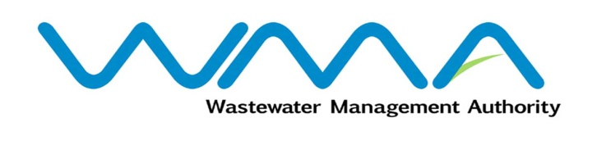 | Invitation for bids (IFb)  (Authorised Under Section 17 of The Public Procurement Act 2006)
WASTEWATER MANAGEMENT AUTHORITY
Procurement Reference: WMA/IFB/2022/751
PROCUREMENT OF REHABILITATION/PROVISION OF SEWERAGE INFRASTRUCTURE AT RESIDENCE VALLÉE DES PRÊTRES & BERNARDIN DE ST. PIERRE ROAD – CHA IV
- The Wastewater Management Authority (WMA) is inviting bids from eligible bidders of Mauritian nationals or entities incorporated in Mauritius, through the Government E-Procurement System for the procurement of Procurement of Rehabilitation/Provision of Sewerage Infrastructure at Residence Vallée Des Prêtres & Bernardin De St.Pierre Road – CHA IV, as more fully described in the bidding document.
- Bidding documents may be downloaded from the E-Procurement System https://eproc.publicprocurement.govmu.org. Reference Number on the system: WMA/IFB/2022/751
- A Pre-Bid Meeting and site visit shall take place on 21 April 2022 as detailed in the Bidding Document.
- Bids must be submitted online on the E-procurement System at latest by 11 May 2022 up to 13:29 hours (local time).
- Bidders who have submitted bids online by the closing date and time shall decrypt and re-encrypt their bids from 11 May 2022 from 14:31 hours (local time) till 13 May 2022 up to 13:29 hours (local time).
- Bids will be opened online in the presence of the bidders/ bidders’ representatives who choose to attend at the address given hereunder on 13 May 2022 as from 13:30 hours:
The Wastewater Management Authority,
9th Floor, The Celicourt,
Sir Celicourt Antelme Street,
Port-Louis,
Mauritius.

- The Wastewater Management Authority reserves the right to accept or reject any bid and to annul the bidding process and reject all bids at any time prior to award of the Contract, without thereby incurring any liability to any Bidder.

12 April 2022

