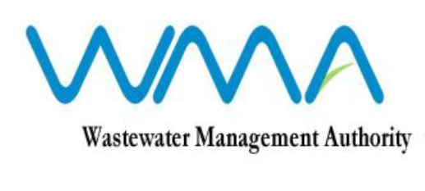

Invitation for Bids (IFB)

(Authorised under Section 17 of the Public Procurement Act 2006)

Procurement for Sludge Re-Engineering at Montagne Jacquot Treatment Plant

Procurement Ref. No: WMA/ONB/480W

1. The Wastewater Management Authority is inviting bids from eligible bidders of Mauritian national or entities incorporated in Mauritius through the Government eProcurement System for Sludge Re-Engineering at Montagne Jacquot Treatment Plant, as morefully described in the bidding document.

2. Bidding documents may be downloaded from the eProcurement System https://eproc.publicprocurement.govmu.org. Reference Number on the system: WMA/IFB/2022/783

3. Bids must be submitted online on the eProcurement System at latest by Wednesday 22 June 2022 up to 13.29 hrs (local Time).

4. Bidders who have submitted bids online by the closing date and time shall decrypt and re-encrypt their bids from Wednesday 22 June 2022 from 14.31 hrs till Friday 24 June 2022 up to 13.29 hrs (local time).

5. Bids will be opened online in the presence of the bidders’ representatives who choose to attend at the address given hereunder on Friday 24 June 2022 up to 16.00 hrs (local time).

Wastewater Management Authority
9th Floor, The Celicourt, Sir Celicourt Antelme Street, Port Louis.

6. The Wastewater Management Authority reserves the right to accept or reject any bid and to annul the bidding process and reject all bids at any time prior to award of the Contract, without thereby incurring any liability to any Bidder.

11 May 2022

