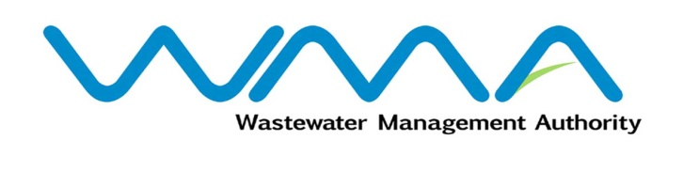 | Invitation for bids (IFb)  (Authorised Under Section 17 of The Public Procurement Act 2006)
WASTEWATER MANAGEMENT AUTHORITY
(Authorised under Section 17 of the Public Procurement Act 2006)

CONTRACT WW263 W - Sewerage Project at Cite La Ferme, Bambous

Procurement Reference No: WMA/IFB/2022/752

CPB Ref: CPB/25/2022

Open National Bidding

- The Wastewater Management Authority (WMA) is inviting bids from eligible bidders of Mauritian nationals or entities incorporated in Mauritius, through the Government E-Procurement System for the procurement of CONTRACT WW263 W - Sewerage Project at Cite La Ferme, Bambous, as more fully described in the bidding document.
- Bidding documents may be downloaded from the E-Procurement System https://eproc.publicprocurement.govmu.org. Reference Number on the system: WMA/IFB/2022/752
- A Pre-Bid Meeting and site visit shall take place on 09 June 2022 as detailed in the Bidding Document.
- Bids must be submitted online on the E-procurement System at latest by Monday 04 July 2022 up to 13:30 hours (local time).
- Bidders who have submitted bids online by the closing date and time shall decrypt and re-encrypt their bids from Monday 04 July 2022 from 14:31 hours (local time) till Wednesday 06 July 2022 up to 14:00 hours (local time).
- Bids will be opened online in the presence of the bidders/ bidders’ representatives who choose to attend at the address given hereunder on Wednesday 06 July 2022 as from 14:01 hours up to 18:00 hours:
The Central Procurement Board
The Conference Room,
1st Floor, Social Security House,
Julius Nyerere Avenue,
Rose Hill,
Mauritius.

- The Wastewater Management Authority reserves the right to accept or reject any bid and to annul the bidding process and reject all bids at any time prior to award of the Contract, without thereby incurring any liability to any Bidder.

Date : 26 May 2022

