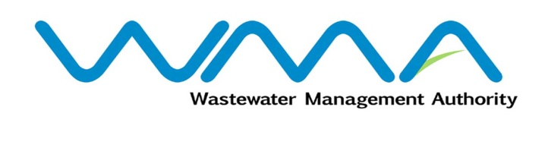 | Invitation for bids (IFb)  (Authorised Under Section 16 of The Public Procurement Act 2006)
WASTEWATER MANAGEMENT AUTHORITY
Procurement Ref. No: WMA/IFB/2022/886
Procurement of Contract WW 488 C – Sewerage Project at Pointe aux Sables – Consultancy Services for Detailed Design and Preparation of Bidding Document

OPEN NATIONAL BIDDING
- The Wastewater Management Authority (WMA) is proceeding with a Request for Proposals online and is inviting potential Consultants of Mauritian nationals or entities incorporated in Mauritius to submit their proposals through the Government e-Procurement System for the Procurement of Contract WW 488 C – Sewerage Project at Pointe aux Sables – Consultancy Services for Detailed Design and Preparation of Bidding Document.
- Request for Proposal Documents may be downloaded from the e-Procurement System https://eproc.publicprocurement.govmu.org. Reference Number on the system: WMA/IFB/2022/886
- Proposals must be submitted online on the e-Procurement System at latest by Wednesday 12 October 2022 up to 13.29 (Local Time).
- Bidders who have submitted bids online by the closing date and time shall decrypt and re-encrypt their bids from Wednesday 12 October 2022 from 14.31 till Friday 14 October 2022 to 13.29.
- Bids will be opened online in the presence of the bidders/ bidders’ representatives who choose to attend at the address given hereunder on Friday 14 October 2022 from 13:30 to 16:00.
The Wastewater Management Authority
Jerningham Street
Port Louis
Mauritius

- The Wastewater Management Authority reserves the right to accept or reject any bid and to annul the bidding process and reject all bids at any time prior to award of the Contract, without thereby incurring any liability to any Bidder.

09 September 2022

