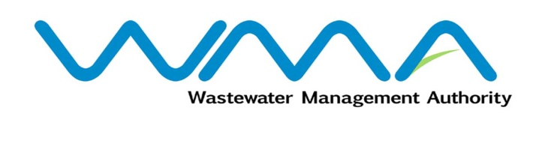 | Invitation for bids (IFb)  (Authorised Under Section 17 of The Public Procurement Act 2006)
WASTEWATER MANAGEMENT AUTHORITY
Contract No.: WMA/OAB/497W
Upgrading of M&E Works At Existing Wastewater Treatment Plant
Procurement Reference: WMA/IFB/2023/1072
- The Wastewater Management Authority (WMA) is inviting bids from eligible bidders of Mauritian nationals or entities incorporated in Mauritius, through the Government E-Procurement System for the procurement of Upgrading of M&E Works At Existing Wastewater Treatment Plant, as more fully described in the bidding document.
- Bidding documents may be downloaded from the E-Procurement System https://eproc.publicprocurement.govmu.org. Reference Number on the system: WMA/IFB/2023/1072
- A Pre-Bid Meeting and site visit shall take place on 23 and 24 March 2023 as detailed in the Bidding Document.
- Bids must be submitted online on the E-procurement System at latest by 18 April 2023 up to 13:30 hours (local time).
- Bidders who have submitted bids online by the closing date and time shall decrypt and re-encrypt their bids from 18 April 2023 2023 from 14:31 hours (local time) till 20 April 2023 up to 14:00 hours (local time).
- Bids will be opened online in the presence of the bidders/ bidders’ representatives who choose to attend at the address given hereunder on 20 April 2023 2023 as from 14:01 hours:
Wastewater Management Authority, Head Office
The Conference Room, Level 3
Jerningham Street
Curepipe
Republic of Mauritius

- The Wastewater Management Authority reserves the right to accept or reject any bid and to annul the bidding process and reject all bids at any time prior to award of the Contract, without thereby incurring any liability to any Bidder.

17 March 2023

