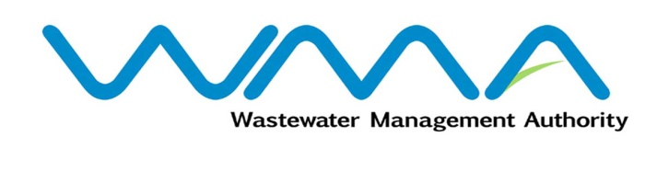 | Invitation for bids (IFb)  (Authorised Under Section 17 of The Public Procurement Act 2006)
WASTEWATER MANAGEMENT AUTHORITY
(Authorised under Section 17 of the Public Procurement Act 2006)

CONTRACT WW500W - Sewerage Diversion Works along Avenue Sivananda (Opposite Vacoas Market)

Procurement Reference No: WMA/IFB/2023/1065

Open National Bidding

- The Wastewater Management Authority (WMA) is inviting bids from eligible bidders of Mauritian nationals or entities incorporated in Mauritius, through the Government E-Procurement System for the procurement of CONTRACT WW500 W - Sewerage Diversion Works along Avenue Sivananda (Opposite Vacoas Market), as more fully described in the bidding document.
- Bidding documents may be downloaded from the E-Procurement System https://eproc.publicprocurement.govmu.org. Reference Number on the system: WMA/IFB/2023/1065
- A Pre-Bid Meeting and site visit shall take place on 07 March 2023 as detailed in the Bidding Document.
- Bids must be submitted online on the E-procurement System at latest by Tuesday 21 March 2023 up to 13:30 hours (local time).
- Bidders who have submitted bids online by the closing date and time shall decrypt and re-encrypt their bids from Tuesday 21 March 2023 from 14:31 hours (local time) till Thursday 23 March 2023 up to 14:00 hours (local time).
- Bids will be opened online in the presence of the bidders/ bidders’ representatives who choose to attend at the address given hereunder on Thursday 23 March 2023 as from 14:01 hours up to 18:00 hours:
Wastewater Management Authority
Jerningham Street
Curepipe
Mauritius.

- The Wastewater Management Authority reserves the right to accept or reject any bid and to annul the bidding process and reject all bids at any time prior to award of the Contract, without thereby incurring any liability to any Bidder.

Date : 28 February 2023

