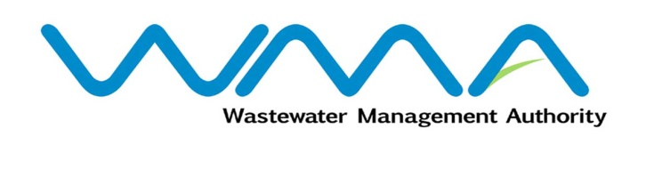 | Invitation for bids (IFb)  (Authorised Under Section 17 of The Public Procurement Act 2006)
WASTEWATER MANAGEMENT AUTHORITY
Contract No.: WMA/ONB/520W
SUPPLY, INSTALLATION, TESTING AND COMMISSIONING OF NEW SLUDGE DEWATERING EQUIPMENT & ASSOCIATED WORKS AT MONTAGNE JACQUOT TREATMENT PLANT

Procurement Reference: WMA/IFB/2023/1193
The Wastewater Management Authority (WMA) is inviting bids from eligible bidders of Mauritian nationals or entities incorporated in Mauritius, through the Government E-Procurement System for the procurement of Supply, Installation, Testing And Commissioning Of New Sludge Dewatering Equipment & Associated Works At Montagne Jacquot Treatment Plant, as more fully described in the bidding document.
- Bidding documents may be downloaded from the E-Procurement System https://eproc.publicprocurement.govmu.org. Reference Number on the system: WMA/IFB/2023 /1193
- A Pre-Bid Meeting and site visit shall take place on 22 September 2023 as detailed in the Bidding Document.
- Bids must be submitted online on the E-procurement System at latest by 10 October 2023 up to 14:00 hours (local time).
- Bidders who have submitted bids online by the closing date and time shall decrypt and re-encrypt their bids from 10 October 2023 from 14:30 hours (local time) till 12 October 2023 up to 14:00 hours (local time).
- Bids will be opened online in the presence of the bidders/ bidders’ representatives who choose to attend at the address given hereunder on 12 October 2023 as from 14:01 hours (local time).
Wastewater Management Authority, Head Office
The Conference Room, Level 3
Jerningham Street
Curepipe
Republic of Mauritius

- The Wastewater Management Authority reserves the right to accept or reject any bid and to annul the bidding process and reject all bids at any time prior to award of the Contract, without thereby incurring any liability to any Bidder.

14 September 2023

