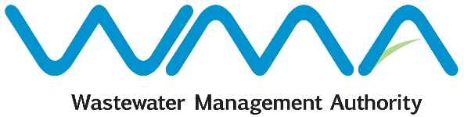

**COMMUNIQUE**

**WASTEWATER ARREARS INCENTIVE SCHEME**

The Wastewater Management Authority (WMA) informs the public that it has introduced the Wastewater Arrears Incentive Scheme, which provides for full waiver of the surcharge of 10% on the wastewater arrears due.

Where outstanding wastewater arrears are fully paid on or before **31 January 2024**, the surcharge of 10% on wastewater arrears will be fully waived.

Payment can be effected at the cash offices of the WMA either at the Head Office, Jerningham St., Curepipe, or at the 3rd floor, Celicourt Building, Sir Célicourt Antelme St., Port-Louis.

Or, the WMA’s bank account can be credited, as per details hereunder:

**Bank: SBM (Mauritius) Ltd**

**Address: State Bank Tower, Port-Louis**

**Account number: 61025100005023**

In case payment is made by bank transfer, please quote the CWA account number.

For any further information, please contact the Finance Section of the WMA on   
**206 3000.**

**Date: 24 November, 2023**