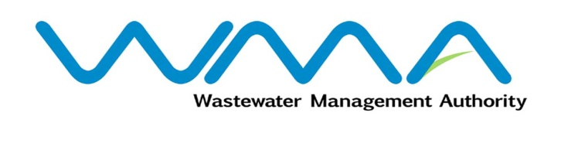 | Invitation for bids (IFb)  (Authorised Under Section 14(2) of The Public Procurement Act 2006)
WASTEWATER MANAGEMENT AUTHORITY
Procurement Reference: CPB/38/2023
Pailles Guibies Sewerage Project Phase 3
Contract WW 509 W - Construction of trunk sewer, reticulation network and CWA connection works

- The Wastewater Management Authority (WMA) is inviting bids from eligible bidders of Mauritian nationals or entities incorporated in Mauritius, through the Government E-Procurement System for the procurement of Pailles Guibies Sewerage Project Phase 3 - Contract WW 509 W - Construction of trunk sewer, reticulation network and CWA connection works, as more fully described in the bidding document.
- Bidding documents may be downloaded from the E-Procurement System https://eproc.publicprocurement.govmu.org. Reference Number on the system: WMA/IFB/2023/1190
- A Pre-Bid Meeting and site visit shall take place on 14 December 2023 as detailed in the Bidding Document.
- Bids must be submitted online on the E-procurement System at latest by 16 January 2024 up to 13:30hrs (Local Time).
- Bidders who have submitted bids online by the closing date and time shall decrypt and re-encrypt their bids from 16 January 2024 from 14:31hrs till 18 January 2024 up to 14:00hrs.
- Bidders shall submit an Original Bid Security amounting to MUR 3,000,000 at the address mentioned below on or before the deadline for submission of bids. The bids security shall be valid up to 14 May 2024.
- Bids will be opened online in the presence of the bidders/ bidders’ representatives who choose to attend at the address given hereunder on 18 January 2024 up to 18:00hrs.
The Central Procurement Board
The Conference Room
Central Procurement Board,
1st Floor, Social Security House,
Julius Nyerere Avenue,
Rose Hill,
Mauritius.

- The Wastewater Management Authority reserves the right to accept or reject any bid and to annul the bidding process and reject all bids at any time prior to award of the Contract, without thereby incurring any liability to any Bidder.

24 November 2023

