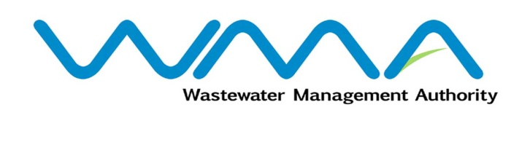 | Invitation for Proposals  (Authorised Under Section 14(2) of The Public Procurement Act 2006)
WASTEWATER MANAGEMENT AUTHORITY
Procurement Reference: WMA/IFB/2023/1199
CPB Reference: CPB/40/2023
PAILLES GUIBIES SEWERAGE PROJECT- PHASE 4
CONTRACT WW510W-FRAMEWORK AGREEMENT FOR DESIGN AND CONSTRUCTION OF HOUSE CONNECTIONS IN THE REGIONS OF PAILLES

- The Wastewater Management Authority (WMA) is inviting proposals from eligible Contractors of Mauritian nationals or entities incorporated in Mauritius, through the Government E-Procurement System for the Pailles Guibies Sewerage Project Phase 4-Contract WW510W- Framework Agreement for Design and Construction of House Connections in the regions of Pailles, as more fully described in the bidding document.
- Bidding documents may be downloaded from the E-Procurement System https://eproc.publicprocurement.govmu.org. Reference Number on the system: WMA/IFB/2023/1199
- Proposals must be submitted online on the E-Procurement System at latest by Tuesday 13 February 2024 up to 13:30 hours (Local Time) at latest.

- Contractors who have submitted proposals online by the closing date and time shall decrypt and re-encrypt their bids on Tuesday 13 February 2024 as from 14:31 hours (Local Time) till Thursday 15 February 2024 at 14:00 hours (Local Time).
- Proposals will be opened online at the address given hereunder on Thursday 15 February 2024 as from 14:01 hours up to 18:00 hours.

The Central Procurement Board
The Conference Room
1st Floor, Social Security House,
Julius Nyerere Avenue,
Rose Hill,
Mauritius.

- The Wastewater Management Authority reserves the right to accept or reject any proposal and to annul the bidding process and reject all bids at any time prior to award of the Contract, without thereby incurring any liability to any Bidder.

28 December 2023

