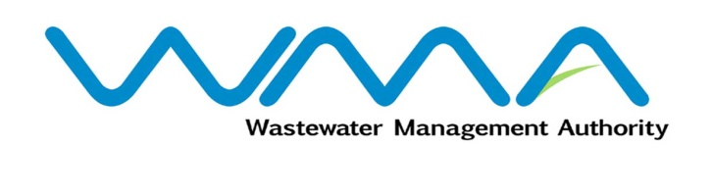 | Invitation for bids (IFb)  (Authorised Under Section 17 of The Public Procurement Act 2006)
WASTEWATER MANAGEMENT AUTHORITY
Contract No.: WMA/ONB/522W
Supply, Installation, Testing And Commissioning of Vertical Screen Washer/Compactor and Associated WORKS AT Wastewater Pumping Stations
Procurement Reference: WMA/IFB/2024/1278
The Wastewater Management Authority (WMA) is inviting bids from eligible bidders of Mauritian nationals or entities incorporated in Mauritius, through the Government E-Procurement System for the procurement of Supply, Installation, Testing And Commissioning of Vertical Screen Washer/Compactor and Associated WORKS AT Wastewater Pumping Stations, as more fully described in the bidding document.
- Bidding documents may be downloaded from the E-Procurement System https://eproc.publicprocurement.govmu.org. Reference Number on the system: WMA/IFB/2024 /1278
- A Pre-Bid Meeting and site visit shall take place on 27 February 2024 as detailed in the Bidding Document.
- Bids must be submitted online on the E-procurement System at latest by the date and time set for bid submission online as per the key Activity Schedule.
- Bidders who have submitted bids online by the closing date and time shall decrypt and re-encrypt their bids within the timeframe set in the key Activity Schedule.
- Bids will be opened online in the presence of the bidders/ bidders’ representatives who choose to attend at the address given hereunder on date and time set for Bid Opening in the key Activity Schedule at the following address:
Wastewater Management Authority, Head Office
The Conference Room, Level 3
Jerningham Street
Curepipe
Republic of Mauritius

- The Wastewater Management Authority reserves the right to accept or reject any bid and to annul the bidding process and reject all bids at any time prior to award of the Contract, without thereby incurring any liability to any Bidder.

20 February 2024

