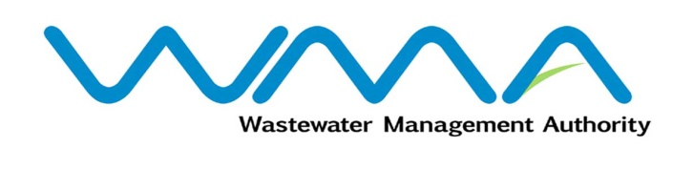 | Invitation for bids (IFb)  (Authorised Under Section 17 of The Public Procurement Act 2006)
WASTEWATER MANAGEMENT AUTHORITY
Contract No.: WMA/ONB/523W
SUPPLY, INSTALLATION, TESTING AND COMMISSIONING OF WASTEWATER PUMPS, ACCESSORIES AND ASSOCIATED WORKS AT ROCHE BOIS WASTEWATER PUMPING STATION

Procurement Reference: WMA/IFB/2024/1287
The Wastewater Management Authority (WMA) is inviting bids from eligible bidders of Mauritian nationals or entities incorporated in Mauritius, through the Government E-Procurement System for the procurement of SUPPLY, INSTALLATION, TESTING AND COMMISSIONING OF WASTEWATER PUMPS, ACCESSORIES AND ASSOCIATED WORKS AT ROCHE BOIS WASTEWATER PUMPING STATION, as more fully described in the bidding document.
- Bidding documents may be downloaded from the E-Procurement System https://eproc.publicprocurement.govmu.org. Reference Number on the system: WMA/IFB/2024/1287
- A Pre-Bid Meeting followed by site visit(s) shall take place on Friday 15 March 2024 at 9:30 hours at the WMA Head Office at the address mentioned below as detailed in the Bidding document.
- Bids must be submitted online on the E-procurement System at latest by Wednesday 03 April 2024 up to 13:30 hours (local time).
- Bidders who have submitted bids online by the closing date and time shall decrypt and re-encrypt their bids from Wednesday 03 April 2024 from 14:31 hours (local time) till Friday 05 April 2024 up to 14:00 hours (local time).
- Bids will be opened online in the presence of the bidders/ bidders’ representatives who choose to attend at the address given hereunder on Friday 05 April 2024 up to 16:00 hours (local time).
Wastewater Management Authority, Head Office
The Conference Room, Level 3
Jerningham Street
Curepipe
Republic of Mauritius

- The Wastewater Management Authority reserves the right to accept or reject any bid and to annul the bidding process and reject all bids at any time prior to award of the Contract, without thereby incurring any liability to any Bidder.

06 March 2024

