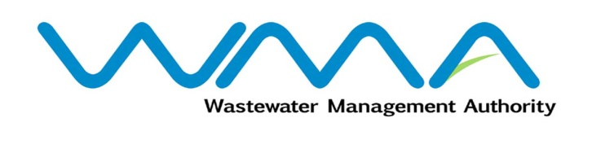 | Invitation for bids (IFb)  (Authorised Under Section 17 of The Public Procurement Act 2006)
WASTEWATER MANAGEMENT AUTHORITY
(Authorised under Section 17 of the Public Procurement Act 2006)

CONTRACT WW512 W - Sewerage Project at Caro Lalo, Vallee des Pretres

CPB Ref: CPB/53/2023
Procurement Reference No: WMA/IFB/2023/1232

Open National Bidding

- The Wastewater Management Authority (WMA) is inviting bids from eligible bidders of Mauritian nationals or entities incorporated in Mauritius, through the Government E-Procurement System for the procurement of CONTRACT WW512 W - Sewerage Project at Caro Lalo, Vallee des Pretres, as more fully described in the bidding document.
- Bidding documents may be downloaded from the E-Procurement System https://eproc.publicprocurement.govmu.org. Reference Number on the system: WMA/IFB/2023/1232
- A Pre-Bid Meeting and site visit shall take place on 18 March 2024 as detailed in the Bidding Document.
- Bids must be submitted online on the E-procurement System at latest by Tuesday 16 April 2024 up to 13:30 hours (Mauritian time).
- Bidders who have submitted bids online by the closing date and time shall decrypt and re-encrypt their bids on Tuesday 16 April 2024 as from 14:31 hours (Mauritian time) till Thursday 18 April 2024 up to 14:00 hours (Mauritian time).
- Bidders shall submit an Original Bid Security amounting to MUR 2,500,000 at the address mentioned below on or before the deadline for submission of bids. The Bid Security shall be valid up to 13 August 2024. Bids will be opened online at the address given hereunder on Thursday 18 April 2024 as from 14:01 hours up to 18:00 hours:
The Conference Room Central Procurement Board
1st Floor, Social Security House,
Julius Nyerere Avenue,
Rose Hill,
Republic of Mauritius.

- The Wastewater Management Authority (WMA) reserves the right to accept or reject any bid and to annul the bidding process and reject all bids at any time prior to award of the Contract, without thereby incurring any liability to any Bidder.

Date : 4 March 2024

