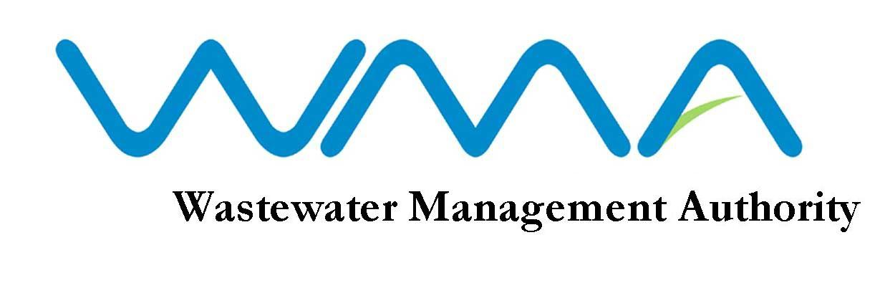
WMA is Recruiting

The Wastewater Management Authority (WMA) is a corporate body which has as its core responsibility the protection of water resources and the health of the population in Mauritius through the management and control of wastewater collection, treatment and disposal. The Authority is expected to handle an investment programme of about 4 billion MUR over the next three years.

The WMA is looking for dynamic, motivated and result-oriented candidates to fill the following positions on permanent/contract basis:

QUALIFICATIONS
1. ENGINEER/SENIOR ENGINEER (CIVIL)
- Registered as Professional Engineer (Civil) with the Council of Registered Professional Engineers of Mauritius under Section 13 of Act No.49 of 1965, as subsequently amended; and

- Computer Literate;

Candidates should produce written evidence of any experience/knowledge claimed.

PERMANENT POSITION
Salary: In the scale of: Rs 33175 x 825 – 35650 x 900 – 37450 x 950 – 42200 x 1300 – 46100 x 1575 – 49250 x 1650 – 54200 x 1700 – 64400 x 1800 - 69800
Benefits: As per PRB 2021

CONTRACTUAL POSITION
Salary: Negotiable and commensurate with qualifications and experience.
Benefits : Travelling Allowance & Gratuity
Duration of contract: Two years, renewable upon satisfactory performance

QUALIFICATIONS
2. TECHNICAL OFFICER (CIVIL)
- A Cambridge School Certificate with credit in at least five subjects including English Language, Mathematics and Physics obtained at not more than two sittings or Passes not below Grade C in at least five subjects including English Language, Mathematics and Physics obtained at not more than two sittings at the General Certificate of Education “Ordinary Level” provided that at one of the sittings, passes have been obtained either (i) in five subjects including English Language with at least Grade C in any two subjects or (ii) in six subjects including English Language with at least Grade C in any one subject.
Note
Candidates not possessing a credit in English Language at the Cambridge School Certificate will also be considered provided they possess passes in at least two subjects at “Principal Level” and one subject at “Subsidiary Level” as well as the General Paper obtained on one certificate at the Cambridge Higher School Certificate Examinations.

- A Cambridge Higher School Certificate or Passes in at least two subjects obtained on one certificate at the General Certificate of Education “Advanced Level”.

- A Diploma in Civil Engineering from a recognized institution.
OR
Equivalent qualifications to A, B and C above acceptable to the Board.

- Candidates should be computer literate.

Qualification at A above should have been obtained prior to qualification at B above.

PERMANENT POSITION
Salary: In the scale of: Rs 21850 x 375 – 22225 x 400 - 23425 x 525 – 26050 x 675 – 27400 x 825 – 35650 x 900 – 37450 x 950 – 42200 x 1300 – 46100 x 1575 – 47675
Benefits: As per PRB 2021

CONTRACTUAL POSITION
Salary: Negotiable and commensurate with qualifications and experience.
Benefits : Travelling Allowance & Gratuity
Duration of contract: Two years, renewable upon satisfactory performance

3. TRAINEE ENGINEER (CIVIL)
QUALIFICATIONS
Candidates should possess a degree or diploma in Engineering recognized by the Council of Registered Professional Engineers of Mauritius as qualifying for registration under Section 13 of the Registered Professional Engineers Council Act No. 49 of 1965 as amended.

SALARY
In the scale of: Rs 26050 x 675 – 27400 x 825 - 28225
Note: Candidates must submit the letter of eligibility from the Council of Registered Professional Engineers of Mauritius.
AGE LIMIT
Candidates applying for permanent position, unless in the public sector, should not have reached their 45th birthday by the closing date of this advertisement.

DUTIES / MODE OF APPLICATION
Application forms and detailed list of duties are available at the Human Resource Section of the WMA and can be downloaded from our website: http://www.wmamauritius.mu.Qualified candidates should submit a comprehensive CV, copies of all academic and professional certificates and written evidence of knowledge/experience claimed. The post applied for should be clearly marked on the left hand corner of the envelope.

CLOSING DATE OF APPLICATION
If you feel challenged by the above positions, and you have the required profile, please send your applications, through registered post, to: The General Manager, Wastewater Management Authority, Jerningham Street, Curepipe, not later than Monday 27 May 2024 at 15.30 hrs.

Note: 1. Only the best qualified candidates will be considered.
2. The WMA reserves the right not to make any appointment as a result of this advertisement.
3. The post applied for should be clearly marked on the left hand corner of the envelope.
4. Late/incomplete application not made on the prescribed form will not be considered.
5. Candidates who possess an equivalent qualification to the prescribed qualification are requested to submit an Equivalence Certificate from Mauritius Qualification Authority or Higher Education Commission, as appropriate.

Wastewater Management Authority
Jerningham Street, Curepipe
Tel : 206 3000/206 3056

08 May 2024

WMA IS AN EQUAL OPPORTUNITY EMPLOYER

