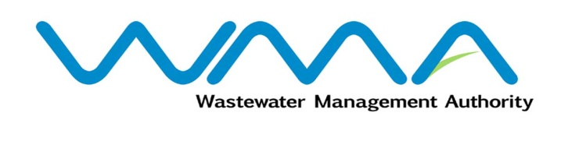 | Invitation for bids (IFb)  (Authorised Under Section 17 of The Public Procurement Act 2006)
WASTEWATER MANAGEMENT AUTHORITY

Procurement Reference: WMA/ONB/15/2024
Procurement of Contract WW543W – A FRAMEWORK AGREEMENT FOR DESIGN AND CONSTRUCTION OF HOUSE CONNECTIONS IN THE SEWERED AREAS OF MAURITIUS
- The Wastewater Management Authority (WMA) is inviting bids from eligible bidders of Mauritian nationals or entities incorporated in Mauritius, through the Government E-Procurement System for the Procurement of Contract WW543W – A FRAMEWORK AGREEMENT FOR DESIGN AND CONSTRUCTION OF HOUSE CONNECTIONS IN THE SEWERED AREAS OF MAURITIUS, as more fully described in the bidding document.
- Bidding documents may be downloaded from the E-Procurement System https://eproc.publicprocurement.govmu.org. Reference Number on the system: WMA/ONB/15/2024
- Bids must be submitted online on the E-procurement System at latest by Tuesday 25 June 2024 up to 13.00 (Local Time).
- Bidders who have submitted bids online by the closing date and time shall decrypt and re-encrypt their bids from Tuesday 25 June 2024 from 14.01 till Thursday 27 June 2024 up to 14.00.
- Bids will be opened online in the presence of the bidders/ bidders’ representatives who choose to attend at the address given hereunder on Thursday 27 June 2024 up to 16.00.
The Wastewater Management Authority,
2nd Floor, Head Office
Jerningham Street,
Curepipe,
Mauritius.
- The Wastewater Management Authority reserves the right to accept or reject any bid and to annul the bidding process and reject all bids at any time prior to award of the Contract, without thereby incurring any liability to any Bidder.

21 May 2024

