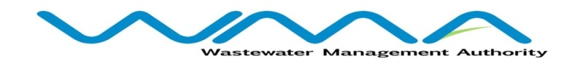

**Award of Procurement Contract**

**Notice under section 40(7) of the Public Procurement act**

This is to notify that following the bidding exercise carried out by the Wastewater Management Authority for the procurement of **PAILLES GUIBIES SEWERAGE PROJECT- PHASE 3-CONTRACT WW 509 W - CONSTRUCTION OF TRUNK SEWER, RETICULATION NETWORK AND CWA CONNECTION WORKS**, the Contract has been awarded to **Sotravic Limitee** for the Contract Amount of **Mauritian Rupees** **Three hundred and Thirty Two Million Nine thousand Two hundred and Thirty Five only** (**MUR 332,009,235.00) (Exclusive of 15% VAT**).

N.Jowaheer

General Manager

Wastewater Management Authority

**Date: 05 June 2024**