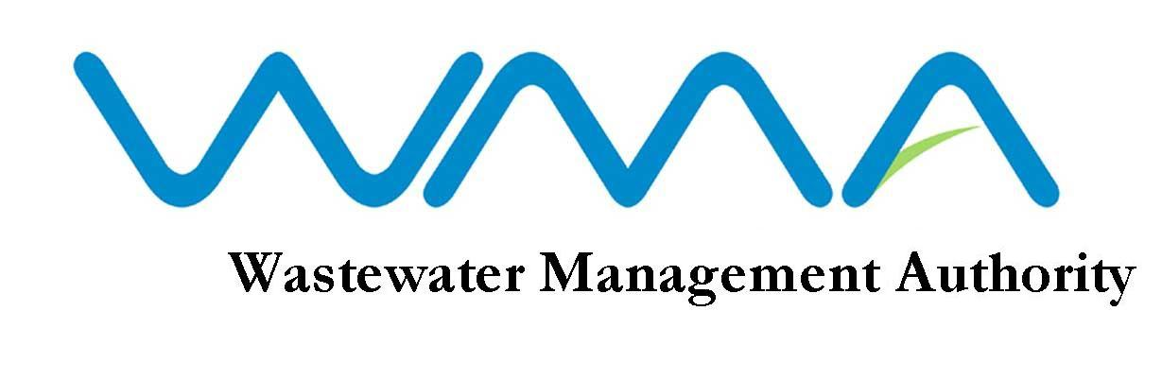
VACANCY

The Wastewater Management Authority (WMA) is a corporate body which has as its core responsibilities the protection of water resources and the health of the population in Mauritius through the management and control of wastewater collection, treatment and disposal. With the expansion of its activities and implementation of new wastewater projects, the Authority is expected to handle an investment programme of about 4 billion MUR over the next three years.

The Authority is inviting applications from high caliber professionals for the position of Internal Auditor/Senior Internal Auditor on permanent or contract basis.

QUALIFICATIONS
INTERNAL AUDITOR/SENIOR INTERNAL AUDITOR – Permanent or Contract Basis

- Member of one of the following bodies-

- The Institute of Chartered Accountants of England and Wales
(b)The Institute of Chartered Accountants of Scotland
(c)The Institute of Chartered Accountants of Ireland
(d)The Association of Chartered Certified Accountants
(e)The Chartered Institute of Management Accountants
(f)The Chartered Institute of Public Finance and Accountancy
OR
An equivalent professional accountancy qualification acceptable to the Board.

EXPERIENCE

(i) Reckons at least two years’ post qualification experience in accountancy and auditing in a senior position;
- Computer literate;
- Possesses good analytical and communication skills; and
- Has a high sense of personal credibility and integrity.

Candidates should produce written evidence of any experience/knowledge claimed

PERMANENT POSITION

Salary: In the scale of: Rs 30700 x 825 – 35650 x 900 – 37450 x 950 – 42200 x 1300 – 46100 x 1575 – 49250 x 1650 – 54200 x 1700 – 64400 x 1800 – 69800
Benefits: As per PRB Report 2021

CONTRACTUAL POSITION

- Salary Scale: Negotiable in the range of Rs 30,700 – Rs 69,800.
- Salary compensation at approved rates.
- Benefits: As per PRB Report 2021
- Duration of contract: 1 year with possibility of renewal.

AGE LIMIT

- Candidates applying for permanent post, unless in the public sector, should not have reached their 45th birthday by the closing date of this advertisement.

- The age limit for employment on contract is 65 years.

DUTIES / MODE OF APPLICATION
Application form and detailed list of duties are available at the Human Resource Section of the WMA and can be downloaded from our website: http://www.wmamauritius.mu.Qualified candidates should submit a comprehensive CV, copies of all academic and professional certificates and evidence of experience claimed. The post applied for should be clearly marked on the top left-hand corner of the envelope.

CLOSING DATE OF APPLICATION
If you feel challenged by the above position and you have the required profile, please send your application, through registered post to: The General Manager, Wastewater Management Authority, Jerningham Street, Curepipe, not later than Wednesday 01 October 2025 at 15.30 hrs.

Note: 1. Only the best qualified candidates will be considered.
2. The WMA reserves the right not to make any appointment as a result of this advertisement.
3. The post applied for should be clearly marked on the left hand corner of the envelope.
4. Late/incomplete application or application not made on the prescribed form will not be considered.
5. Candidates who possess an equivalent qualification to the prescribed qualification are requested to submit an Equivalence Certificate from Mauritius Qualification Authority/Tertiary Education Commission, as appropriate.

Wastewater Management Authority
Jerningham Street, Curepipe
Tel : 206 3000/206 3056

16 September 2025

WMA IS AN EQUAL OPPORTUNITY EMPLOYER



