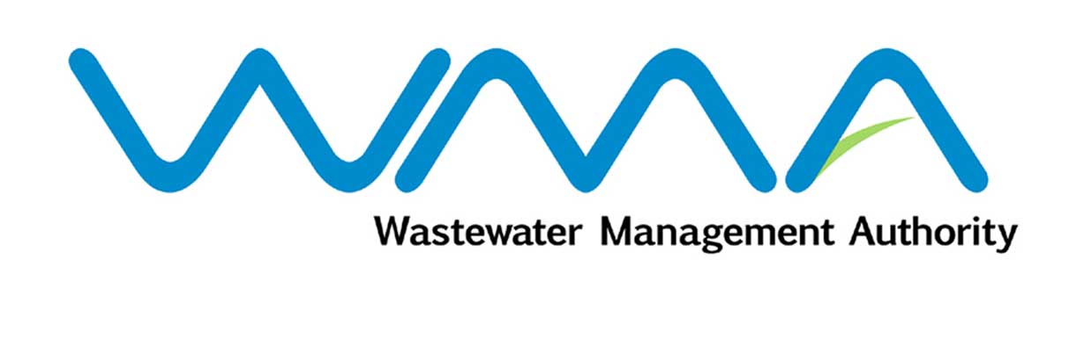

Post of Internal Auditor

Duties:

- To be responsible for the day to day management of the Internal Audit Section and to report directly to the General Manager on all matters pertaining to internal audit.

- To devise, plan and monitor programmes of checks and internal audit at the Wastewater Management Authority.

- To maintain, review and introduce effective internal control systems and procedures throughout the Authority.

- To identify weaknesses in management and accounting systems and submit recommendations for remedy and improvement.

- To ensure that statutory provisions as well as internal rules and regulations are complied with.

- To ascertain that policies and plans established by the Board are complied with.

- To submit to the General Manager monthly reports on activities carried out and a quarterly report for submission to the Board.

- To review audit reports and ensure that the recommendations made therein are satisfactorily implemented.

- To train staff of the Internal Audit Section.

- To use ICT in the performance of his duties.

- To perform such other duties directly related to the main duties listed above or related to the delivery of the output and results expected from the Internal Auditor in the roles ascribed to him.

