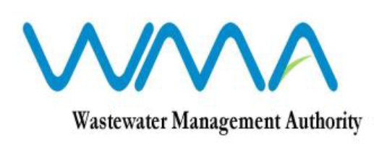

INVITATION FOR PROPOSALS
(Authorised under Section 16 of the Public Procurement Act 2006)
Procurement Reference No.: OAB/17/2025
e-Procurement Reference No.: WMA/IFB/2025/1720
OPEN ADVERTISED BIDDING

Contract WW 570C - Procurement for the Consultancy Services for Feasibility Study, Detailed Design and Preparation of Bidding Document for Automation and Centralised SCADA System for Wastewater Pumping Stations and Treatment Plants

1. The Wastewater Management Authority (WMA) is inviting proposals from suitably qualified Consultancy Firms, through the Government E-Procurement System for Consultancy Services for Feasibility Study, Detailed Design and Preparation of Bidding Document for Automation and Centralised SCADA System for Wastewater Pumping Stations and Treatment Plants, as more fully described in the bidding document.

2. Request for Proposal document may be downloaded from the E-Procurement System https://eproc.publicprocurement.govmu.org. Reference Number on the system: WMA/IFB/2025/1720

3. Pre – Proposal Conference
Consultants are invited to attend a pre-proposal conference that will be held through online video conference on Thursday 27 November 2025 at 13.00 hrs Mauritian time (GMT+4).
The Link will be provided through an Addendum at least three (3) days from the scheduled date.

4. Proposals must be submitted online on the e-procurement System at latest by Wednesday 17 December 2025 up to 13.29 hrs (Mauritian time).

5. Consultants who have submitted bids online by the closing date and time shall decrypt and re-encrypt their bids from Wednesday 17 December 2025 from 14.31 hrs till Friday 19 December 2025 up to 14.00 hrs (Mauritian time).

6. Proposals will be opened online in the presence of the bidder’s representatives who choose to attend at the address given hereunder on Friday 19 December 2025 as from 14.01 hrs (Mauritian time).

The Wastewater Management Authority,
3rd Floor, Conference Room
Jerningham Street,
Curepipe
Mauritius

7. The Wastewater Management Authority reserves the right to accept or reject any proposal and to annul the bidding process and reject all proposals at any time prior to award of the Contract, without thereby incurring any liability to any Bidder.

10 November 2025

