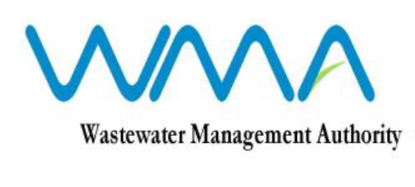

INVITATION FOR PROPOSALS
(Authorised under Section 16 of the Public Procurement Act 2006)
Procurement Reference No.: OAB/04/2026
e-Procurement Reference No.: WMA/IFB/2026/1873
OPEN ADVERTISED BIDDING

Contract WW 580C - Procurement for the Consultancy Services for Feasibility Study, Detailed Design and Preparation of Bidding Document for Automation and Centralised SCADA System for Wastewater Pumping Stations and Treatment Plants

1. The Wastewater Management Authority (WMA) is pleased to invite eligible and qualified Local and International Firms to submit their best proposals through the Government eProcurement System for the consultancy services for Feasibility Study, Detailed Design and Preparation of Bidding Document for Automation and Centralised SCADA System for Wastewater Pumping Stations and Treatment Plants, as more fully described in the bidding document.

2. Request for Proposal document may be downloaded from the E-Procurement System https://eproc.publicprocurement.govmu.org. Reference Number on the system: WMA/IFB/2026/1873

3. Pre – Proposal Conference
Consultants are invited to attend a pre-proposal conference that will be held through online video conference on Thursday 13 August 2026 at 13.00 hrs Mauritian time (GMT+4).
Video Conference link: Join: https://teams.microsoft.com/meet/377579478374420?p=Vvi3H7rKPJmRMeoQxY
Meeting ID: 377 579 478 374 420
Passcode: kx3V9FR3
4. Proposals must be submitted online on the e-procurement System at latest by Wednesday 09 September 2026 up to 13.29 hrs (Mauritian time).

5. Consultants who have submitted bids online by the closing date and time shall decrypt and re-encrypt their bids from Wednesday 09 September 2026 from 14.31 hrs till Friday 11 September 2026 up to 14.00 hrs (Mauritian time).

6. Proposals will be opened online in the presence of the bidder’s representatives who choose to attend at the address given hereunder on Friday 11 September 2026 as from 14.01 hrs (Mauritian time).

The Wastewater Management Authority,
3rd Floor, Conference Room
Jerningham Street,
Curepipe
Mauritius

7. The Wastewater Management Authority reserves the right to accept or reject any proposal and to annul the bidding process and reject all proposals at any time prior to award of the Contract, without thereby incurring any liability to any Bidder.

22 July 2026

